SBDH – konfiguration

i SDN-beskyttet eDelivery domæne på sundhedsområdet

Version af 19-06-2023 13:54

Indhold

2 Errata 5

3 Referencer 6

4 SBDH (Standard Business Document Header) 8

4.1 Generelt 8

4.1.1 SBDH for en MedCom meddelelse og en MedCom kvittering 8

4.1.2 SBDH for en SBDH kvittering 9

4.2 StandardBusinessDocument 9

4.3 SBDH - Generelle elementer 9

4.3.1 HeaderVersion 9

4.3.2 Sender 9

4.3.2.1 Identifier 9

4.3.2.2 Sender eksempel: 10

4.3.3 Receiver 10

4.3.3.1 Identifier 10

4.3.3.2 Receiver eksempel: 10

4.3.4 DocumentInformation 10

4.3.4.1 Standard 10

4.3.4.2 TypeVersion 10

4.3.4.3 InstanceIdentifier 11

4.3.4.4 Type 11

4.3.4.5 MultipleType 12

4.3.4.6 CreationDateAndTime 12

4.3.4.7 DocumentInformation samlet meddelelses eksempel 12

4.3.4.8 DocumentInformation samlet kvitteringseksempel 12

4.3.5 Manifest (bevidst udeladt i Pilotversionen) 12

4.4 SBDH BusinessScope - eDelivery generel meddelelseskommunikation 13

4.4.1 Sammenhæng til SMP 13

*4.4.2* DOCUMENTID 13

4.4.2.1 DOCUMENTID Eksempel: 14

4.4.3 PROCESSID 14

4.4.3.1 PROCESSID Eksempel: Brug i 4-corner model 15

4.4.3.2 PROCESSID Eksempel: Brug i 3-corner model (gateway løsning) 15

4.5 SBDH BusinessScope – sundhedsmeddelelseskommunikation 16

4.5.1 Scope – message statistik metadata 16

4.5.1.1 SENDERID 16

4.5.1.2 RECEIVERID 17

4.5.1.3 STATISTICALCODE 17

4.5.2 Scope – message metadata 18

4.5.2.1 MESSAGEIDENTIFIER 18

4.5.2.2 EPISODEOFCAREIDENTIFIER 18

4.6 SBDH BusinessScope - Dokumentdeling 19

4.6.1.1 AUTHORINSTITUTION 19

4.6.1.2 CLASSCODE 19

4.6.1.3 CONFIDENTIALITYCODE 20

4.6.1.4 CREATIONTIME 20

4.6.1.5 ENTRYUUID 20

4.6.1.6 FORMATCODE 21

4.6.1.7 HEALTHCARE_FACILITY_TYPE_CODE 21

4.6.1.8 INTENDEDRECIPIENT 22

4.6.1.9 LANGUAGECODE 22

4.6.1.10 LEGALAUTHENTICATOR 22

4.6.1.11 MIMETYPE 22

4.6.1.12 OBJECTTYPE 23

4.6.1.13 PATIENTID 23

4.6.1.14 PRACTICESETTINGCODE 23

4.6.1.15 SOURCEPATIENTID 23

4.6.1.16 SOURCEPATIENTINFO 24

4.6.1.17 TITLE 24

4.6.1.18 TYPECODE 25

4.7 SBDH Reliable messaging & eDelivery SBDH-kvitteringer 26

4.7.1 Reliable messaging - BusinessService Request 26

4.7.1.1 MedCom_SBDH_ReceiptAcknowledgement - Request 27

4.7.1.2 CorrelationInformation 27

4.7.1.3 CorrelationInformation samlet eksempel 28

4.7.1.4 SBDH BusinessServices - Request 28

4.7.1.5 SBDH BusinessServices - Request eksempel 29

4.7.1.6 Reliable messaging - BusinessService Request samlet eksempel 29

4.7.2 Reliable messaging - BusinessService Response 30

4.7.2.1 MedCom_SBDH_ReceiptAcknowledgement - Response 30

4.7.2.2 CorrelationInformation 30

4.7.2.3 SBDH BusinessServices - Response 31

4.7.2.4 SBDH BusinessServices - Response eksempel 32

4.7.2.5 Reliable messaging - BusinessService Response samlet eksempel 32

4.7.3 SBDH ReceiptAcknowledgement 33

4.7.4 Receipt Acknowledgement Exception 35

4.8 SBDH BinaryContent – den indeholdte meddelelse 38

5 SBDH i brugsscenarier 39

5.1 4-corner 39

5.2 3-corner (gateway-scenarier) 39

6 SMP (Service Metadata Publisher) 40

7 Bilag A: Policies for konfiguration af SMP og SBDH 40

7.1.1 Generelt vedrørende identifiers 40

7.1.2 Konfiguration af ParticipantIdentifier (SMP)/Party Identification (SBDH) 41

7.1.2.1 SMP 41

7.1.2.2 Konfiguration af Party Identification (SBDH) 41

7.1.2.3 [TBD] POLICY 14x XML attributes for Party Identifiers in MedCom documents 42

7.1.3 Konfiguration af DocumentIdentifier 43

7.1.3.1 Policies on Identifying Document Types (supported by MedCom) 43

7.1.3.2 [TBD] POLICY 18x Specifying Customization Identifiers in MedCom documents 43

7.1.4 Konfiguration af ProcessIdentifier 44

7.1.4.1 Policy for MedCom Process Identifiers 44

7.1.5 Konfiguration af “Transport Profiles” i SMP 46

7.1.5.1 Policy on Identifying Transport Profiles in SMP 46

# Errata

| **Kapitel** | **Rettelse** | **Dok version** |
| --- | --- | --- |
|  |  |  |

# Referencer

| **Reference** | **Navn** | **Filnavn** | **Placering** |
| --- | --- | --- | --- |
| [Policy_identifiers] | PEPPOL Transport Infrastructure  ICT - Models  Policy for use of Identifiers, Version: 4.0 | PEPPOL-EDN-Policy-for-use-of-identifiers-4.0-2019-01-28.pdf | <https://docs.peppol.eu/edelivery/policies/PEPPOL-EDN-Policy-for-use-of-identifiers-4.0-2019-01-28.pdf> |
| [DKEDEL_PIV_CodeList] | DK_EDEL Code Lists - Participant identifier schemes v7.2 | DK_EDEL Code Lists - Participant identifier schemes v7.2.xlsx | <https://medcomtest.sharepoint.com/:x:/s/MedComModerniseringsPilot2020/EQSLr01jvoROrbkqCd6yhvQBLUyxUPPAP_MX2WTBjMGRaQ?e=THfhXm> |
| [DKEDEL_TP_CodeList] | Dansk eDelivery Code Lists - Transport profiles v7.2 | Dansk eDelivery Code Lists - Transport profiles v7.2.xlsx | <https://medcomtest.sharepoint.com/:x:/s/MedComModerniseringsPilot2020/EdlEjIlLDadJuy7RjD926bkB0X5X-0m1JuQG_VF8Je2f-g?e=4b7jF8> |
| [DKEDEL_DT_CodeList] | Dansk eDelivery Code Lists - Document types v7.2.  (MedCom meddelelser) | Dansk eDelivery Code Lists - Document types v7.2.xlsx | <https://medcomtest.sharepoint.com/:x:/r/sites/MedComModerniseringsPilot2020/Delte%20dokumenter/eDelivery/Dansk%20eDelivery/DK_EDEL%20Code%20Lists%20-%20Document%20types%20v7.2%20-%2020211122.xlsx?d=wf68cc9cce4594eae8b8c8d26c828280c&csf=1&web=1&e=H5LYNJ> |
| [PEPPOL_SBDH12] | PEPPOL Business Message Envelope (SBDH) 1.2 | PEPPOL-EDN-Business-Message-Envelope-1.2-2019-02-01.pdf | <https://medcomtest.sharepoint.com/:b:/s/MedComModerniseringsPilot2020/EeWbN0HnqcZMhel_56f8tCcB7G-boIwnP5PeoMAsDU5lCQ?e=gXR3cY> |
|  |  |  |  |
| [DDS Metadata] | DDS Metadata-v096 | DDS Metadata-v096.docx | <http://svn.medcom.dk/svn/drafts/Standarder/IHE/DK_profil_metadata/Metadata-v096.docx> |
| [DDS_Metadata- ValueSets] | DK-IHE_Metadata-Common_Code_systems-Value_sets | DK-IHE_Metadata-Common_Code_systems-Value_sets.xlsx | <http://svn.medcom.dk/svn/drafts/Standarder/IHE/OID/DK-IHE_Metadata-Common_Code_systems-Value_sets.xlsx> |
| [ebxmlbp] | ebxmlbp-v2.0.4-Spec-os-en | ebxmlbp-v2.0.4-Spec-os-en.pdf | <https://docs.oasis-open.org/ebxml-bp/2.0.4/OS/spec/ebxmlbp-v2.0.4-Spec-os-en.pdf> |
| [SBDHschema] | Standard Business Document Header Schema for pilot | MedComStandardBusinessDocumentHeader_20210217.xsd | <https://medcomtest.sharepoint.com/:u:/s/MedComModerniseringsPilot2020/EdudZoIaoXtAgC_PhWGKvCwBscQxkP54bYLqWQPx86SxuQ?e=bITgGk> |



# SBDH (Standard Business Document Header)

## Generelt

StandardBusinessDocumentHeader (SBDH) er en konvolutspecifikation udstedt af GS1 og profileret til anvendelse i PEPPOL. Vi følger i dansk eDelivery på sundhedsområdet konventionerne, som er udlagt i PEPPOLs profilering, men udvider den også til at kunne passe på sundhedsområdet. SBDH er dog ingenting uden en omgivende container, og derfor er der en tynd wrapper rundt om SBDH, nemlig StandardBusinessDocument, som dog kun indeholder to elementer:

StandardBusinessDocument

* StandardBusinessDocumentHeader
* BinaryContent

Selvom StandardBusinessDocument, som sådan er konvolutten, bruges termen SBDH generelt om hele konvolutten, da det er dette indhold som er særligt interessant i meddelelsesudvekslingen.

BinaryContent er elementet som indeholder en base64-kodet meddelelse eller kvittering for en afsendt SBDH-konvolut.

I det følgende beskrives indholdet i SBDH.

Indholdet i SBDH er for en stor dels vedkommende bestemt af hvorledes

* de samme informationer registreres i SMP
* sammenhængen er til DokumentDelingSservicen DDS
* sammenhængen er til MedComs statistik
* sammenhængen er til SBDH kvitteringen

SBDH har en struktur, der overordnet er delt ind i følgende elementer:

* HeaderVersion
* Sender
* Receiver
* DocumentInformation
* Manifest
* BusinessScope

Hvor de fleste elementer har almindeligt fokus på meddelelsesudveksling generelt og samspillet med SMP, giver særligt BusinessScope mulighed for at sætte sundhedsorienterede aftryk i specifikationen.

Manifest er dog bevidst ikke i brug i nærværende version

### SBDH for en MedCom meddelelse og en MedCom kvittering

I en SBDH for en MedCom meddelelse og en MedCom kvittering er der følgende metadata:

* Generelle SBDH metadata
* Metadata for eDelivery generel meddelelseskommunikation
* Metadata for sundhedsmeddelelseskommunikation
* Metadata for Dokumentdeling
* Metadata for Reliable messaging - BusinessService Request

### SBDH for en SBDH kvittering

I en SBDH for en SBDH kvittering er der følgende metadata:

* Generelle SBDH metadata
* Metadata for eDelivery generel meddelelseskommunikation
* Metadata for sundhedsmeddelelseskommunikation
  + Kun SENDERID, RECEIVERID og STATISTICALCODE
* Metadata for Reliable messaging - BusinessService Response

## StandardBusinessDocument

StandardBusinessDocument er som nævnt SBDHs omgivende container, og er kun en tynd wrapper rundt om SBDH, og indeholder kun to elementer:

* + - StandardBusinessDocumentHeader
    - BinaryContent (base64-kodet)

## SBDH - Generelle elementer

SBDH består af elementerne i nedenstående figur, som gennemgåes 1 for 1 i det følgende.

### HeaderVersion

Altid

<HeaderVersion>1.0</HeaderVersion>

### Sender

#### Identifier

Altid på følgende form:

<Sender>

<Identifier Authority="iso6523-actorid-upis">

0088:[eMessage/[LetterType]/Sender/EANIdentifier]

</Identifier>

</Sender>

Hvor værdien efter 0088: afspejler GLN-typenummeret.

#### Sender eksempel:

<Sender>

<Identifier Authority="iso6523-actorid-upis">0088:5790000121526</Identifier>

</Sender>

### Receiver

#### Identifier

Altid på følgende form:

<Receiver>

<Identifier Authority="iso6523-actorid-upis">

0088:[eMessage/[LetterType]/Receiver/EANIdentifier]

</Identifier>

</Receiver>

Hvor værdien efter 0088: afspejler GLN-typenummeret.

#### Receiver eksempel:

<Receiver>

<Identifier Authority="iso6523-actorid-upis">0088:5790000201389</Identifier>

</Receiver>

### DocumentInformation

#### Standard

Meddelelse:

<Standard>

urn:dk:healthcare:medcom:oioxml:schema:xsd:

+ [eMessage/[LetterType]]

</Standard>

Kvittering:

Altid

<Standard>ebbp-signals</Standard>

##### Eksempel:

Meddelelseseksempel:

<Standard>

urn:dk:healthcare:medcom:oioxml:schema:xsd:HospitalReferral

</Standard>

Kvitteringseksempel:

<Standard>ebbp-signals</Standard>

#### TypeVersion

Meddelelse:

<TypeVersion>[eMessage/[LetterType]/Letter/VersionCode]</TypeVersion>

Kvittering:

Altid

<TypeVersion>ebbp-signals-2.0</TypeVersion>

##### Eksempel:

Meddelelseseksempel:

<TypeVersion>XH0130R</TypeVersion>

Kvitteringseksempel:

<Type>ebbp-signals-2.0</Type>

#### InstanceIdentifier

InstanceIdentifier vil blive genereret af den afsendende MSH. Hvis der konverteres fra VANSenvelope kan VANSenvelope/EnvelopeIdentifier evt. genbruges.

<InstanceIdentifier>

[VANSenvelope/SenderID] + ”:” + [VANSenvelope/EnvelopeIdentifier] </InstanceIdentifier>

<InstanceIdentifier>[generated UUID]</InstanceIdentifier>

##### Eksempel:

**Meddelelseseksempel:**

<!-- [VANSenvelope/SenderID] + ”:” + [VANSenvelope/EnvelopeIdentifier] -->

<InstanceIdentifier>5790001354145:54382645943297</InstanceIdentifier>

Eller

<!-- [generated UUID] -->

<InstanceIdentifier>b7faca8e-e908-47bb-b323-0eb8a854c558</InstanceIdentifier>

#### Type

Meddelelse:

<Type>[eMessage/[LetterType]/Letter/TypeCode]</Type>

MedCom Kvittering:

<Type>[eMessage/[LetterType]/Letter/StatisticalCode]</Type>

SBDH Kvittering:

<Type>[Kvitteringstype]</Type>

Kvitteringstype har følgende udfaldsrum:

Udfaldsrum for disse ebXML Business Process Signals er:

* ReceiptAcknowledgement
* ReceiptException
* AcceptanceAcknowledgement (bruges ikke i piloten)

##### Eksempel:

Meddelelseseksempel:

<Type>XREF01</Type>

MedCom Kvittering:

<Type>XCTL03</Type>

Kvitteringseksempel:

<Type>ReceiptAcknowledgement</Type>

#### MultipleType

Altid false:

<MultipleType>false</MultipleType>

##### Eksempel:

Eksempel:

<MultipleType>false</MultipleType>

#### CreationDateAndTime

Altid på formen: [YYYY-MM-DD]T[TT-MM-SS]+[offset-to-UTC]

<CreationDateAndTime>

[YYYY-MM-DD]T[TT-MM-SS]+[offset-to-UTC]

</CreationDateAndTime>

##### Eksempel:

<CreationDateAndTime>2020-11-06T16-19-00+01.00</CreationDateAndTime>

#### DocumentInformation samlet meddelelses eksempel

<DocumentIdentification>

<Standard>

urn:dk:healthcare:medcom:oioxml:schema:xsd:HospitalReferral

</Standard>

<TypeVersion>XH0130R</TypeVersion>

<InstanceIdentifier>

9a6ff822-08de-5a6f-9670-9fa4b9d2f0dc

</InstanceIdentifier>

<Type>XREF01</Type>

<MultipleType>false</MultipleType>

<CreationDateAndTime>2020-11-06T16-19-00+01.00</CreationDateAndTime>

</DocumentIdentification>

#### DocumentInformation samlet kvitteringseksempel

<DocumentIdentification>

<Standard>ebbp-signals</Standard>

<TypeVersion>ebbp-signals-2.0</TypeVersion>

<InstanceIdentifier>

9a6ff822-08de-5a6f-9670-9fa4b9d2f0dx

</InstanceIdentifier>

<Type>ReceiptAcknowledgement</Type>

<MultipleType>false</MultipleType>

<CreationDateAndTime>2020-11-06T16-19-00+01.00</CreationDateAndTime>

</DocumentIdentification>

### Manifest (bevidst udeladt i Pilotversionen)

## SBDH BusinessScope - eDelivery generel meddelelseskommunikation

### Sammenhæng til SMP

i eDelivery kommunikationen udgør SBDH’ens Scope struktur med de to typer, DOCUMENTID og PROCESSID, foruden de allerede gennemgåede elementer i Sender og Receiver, den direkte sammenhæng til SMP’ens DOCUMENTID og PROCESSID. I det følgende beskrives netop disse 2 Type elementer i SBDH’ens overordnede BusinessScope struktur.

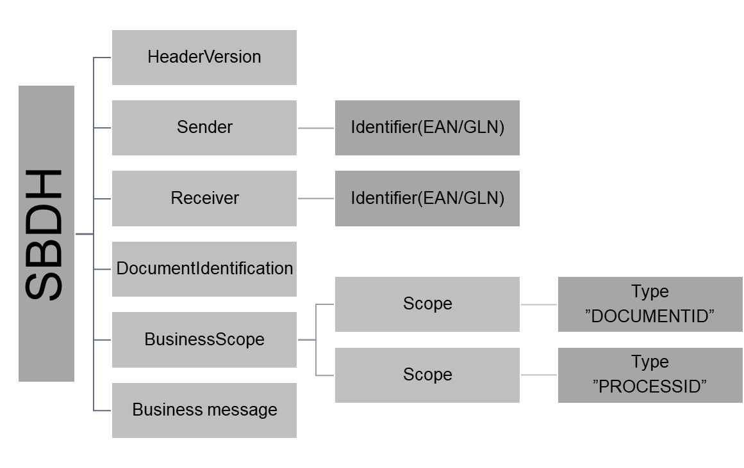

### DOCUMENTID

Værdien i InstanceIdentifier er identisk med den tilsvarende SMP-registrering

Værdierne hentes fra MedComs standardkatalog og er her repræsenteret ved de værdier, som de har i MedCom meddelelserne. Se bogmærke: [DKEDEL_DT_CodeList]

Ift. det oprindeligt intentionerede fjernes dobbelt ”##” og ”::” fra konstruktionen af InstanceIdentifier, da den aktuelle konfiguration af SMP fra CEF ikke kan håndtere disse så værdierne kan fremsøges igen. Dermed må SBDH’s DOCUMENTID ændres tilsvarende.

DOCUMENTID MedCom Meddelelser:

<Scope>

<Type>DOCUMENTID</Type>

<InstanceIdentifier>

urn:dk:healthcare:medcom:messaging:oioxml:schema:xsd:[eMessage/[LetterType]]#urn:dk:healthcare:medcom:messaging:oioxml:schema:xsd:[eMessage/[LetterType]]/[Letter/TypeCode]:[eMessage/[LetterType]]/[Letter/VersionCode]

</InstanceIdentifier>

<Identifier>urn:dk:healthcare:medcom:messaging:oioxml</Identifier>

</Scope>

DOCUMENTID MedCom Kvitteringer:

<Scope>

<Type>DOCUMENTID</Type>

<InstanceIdentifier>

urn:dk:healthcare:medcom:messaging:oioxml:schema:xsd:[eMessage/[LetterType]]#urn:dk:healthcare:medcom:messaging:oioxml:schema:xsd:[eMessage/[LetterType]]/[Letter/***StatisticalCode***]:[eMessage/[LetterType]]/[Letter/VersionCode]

</InstanceIdentifier>

<Identifier>urn:dk:healthcare:medcom:messaging:oioxml</Identifier>

</Scope>

#### DOCUMENTID Eksempel:

##### DOCUMENTID MedCom Meddelelseseksempel:

<Scope>

<Type>DOCUMENTID</Type>

<InstanceIdentifier>

urn:dk:healthcare:medcom:messaging:oioxml:schema:xsd:HospitalReferral#urn:dk:healthcare:medcom:messaging:oioxml:schema:xsd:HospitalReferral:XREF01:XH0131R

</InstanceIdentifier>

<Identifier>urn:dk:healthcare:medcom:messaging:oioxml</Identifier>

</Scope>

##### DOCUMENTID MedCom Kvitteringseksempel:

<Scope>

<Type>DOCUMENTID</Type>

<InstanceIdentifier>

urn:dk:healthcare:medcom:messaging:oioxml:schema:xsd:PositiveReceipt#urn:dk:healthcare:medcom:messaging:oioxml:schema:xsd:PositiveReceipt:XCTL03:XC0330Q

</InstanceIdentifier>

<Identifier>urn:dk:healthcare:medcom:messaging:oioxml</Identifier>

</Scope>

##### DOCUMENTID SBDH Kvitteringseksempel:

<Scope>

<Type>DOCUMENTID</Type>

<InstanceIdentifier>

urn:dk:healthcare:medcom:messaging:ebxml:schema:xsd:SBDHReceiptAcknowledgement

</InstanceIdentifier>

<Identifier>urn:dk:healthcare:medcom:messaging:ebxml</Identifier>

</Scope>

### PROCESSID

Værdien i InstanceIdentifier er identisk med den tilsvarende ProcessId SMP-registrering.

Pga. udfordringer med SMP er også ProcessId ændret

<Scope>

<Type>PROCESSID</Type>

<InstanceIdentifier>

[Process Identifier value]

</InstanceIdentifier>

<Identifier>dk-messaging-procid</Identifier>

</Scope>

Værdierne hentes fra nedenstående liste:

**dk-messaging Process Identifier values**

|  |  |  |
| --- | --- | --- |
| **Process** | **Process Identifier value (InstanceIdentifier)** | **Identifier type** |
| sdn-emergence | sdn-emergence | dk-messaging-procid |
| sdn-distribution | sdn-distribution | dk-messaging-procid |
| fod-emergence | fod-emergence | dk-messaging-procid |
| fod-distribution | fod-distribution | dk-messaging-procid |

#### PROCESSID Eksempel: Brug i 4-corner model

I 4-corner modellen sendes emergence-registreringen med fra SMP, således at afsenders AP kan slå finalreceipient op korrekt i SMP.

##### PROCESSID Eksempel:

<Scope>

<Type>PROCESSID</Type>

<InstanceIdentifier>sdn-emergence</InstanceIdentifier>

<Identifier>dk-messaging-procid</Identifier>

</Scope>

#### PROCESSID Eksempel: Brug i 3-corner model (gateway løsning)

I 3-corner modellen, hvor en gateway er involveret i forsendelseskæden, er det nødvendigt at konfigurere den første afsendelse lig den i 4-corner modellen, mens gatewayen er nødt til at påføre ny PROCESSID (og i øvrigt ny DocumentIdentification/InstanceIdentifier), således at gateway’ens AP kan slå finalreceipient korrekt op i SMP.

##### PROCESSID eksempel forsendelse fra C1(afsender) til C2(gateway):

<Scope>

<Type>PROCESSID</Type>

<InstanceIdentifier>fod-emergence</InstanceIdentifier>

<Identifier>dk-messaging-procid</Identifier>

</Scope>

##### PROCESSID eksempel forsendelse fra C2(gateway) til C3(modtager):

<Scope>

<Type>PROCESSID</Type>

<InstanceIdentifier>fod-distribibution</InstanceIdentifier>

<Identifier>dk-messaging-procid</Identifier>

</Scope>

## SBDH BusinessScope – sundhedsmeddelelseskommunikation

### Scope – message statistik metadata

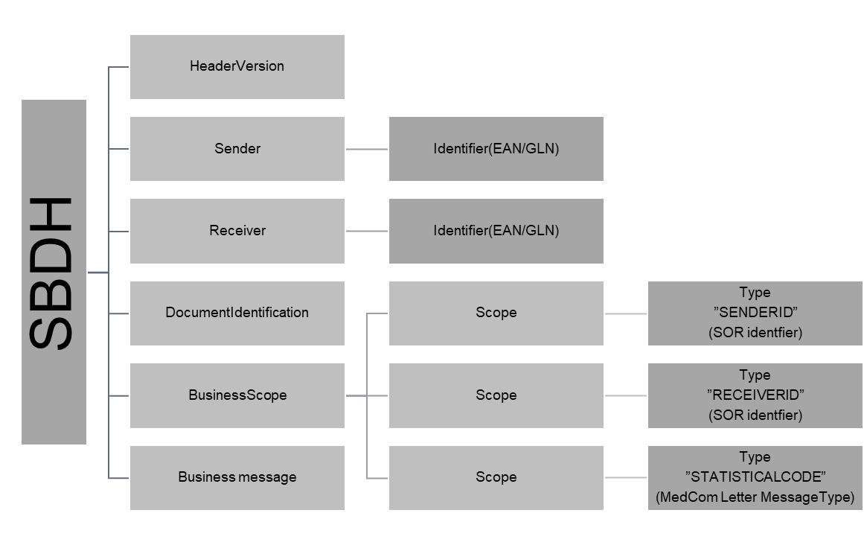

#### SENDERID

Afsenders SOR-identifier til brug for MedCom statistik. Ifm. MedCom kvitteringer anvendes EANIdentifier.

SENDERID MedCom meddelelser:

<Scope>

<Type>SENDERID</Type>

<InstanceIdentifier>

[Emessage/[LetterType]/Sender/Identifier]

</InstanceIdentifier>

 <Identifier>

dk-medcom-[Emessage/[LetterType]/Sender/IdentifierCode]

</Identifier>

</Scope>

SENDERID MedCom Kvitteringer:

<Scope>

<Type>SENDERID</Type>

<InstanceIdentifier>

[Emessage/[LetterType]/Sender/EANIdentifier]

</InstanceIdentifier>

 <Identifier>dk-medcom-EANIdentifier</Identifier>

</Scope>

##### SENDERID MedCom meddelelseseksempel:

<Scope>

<Type>SENDERID</Type>

<InstanceIdentifier>1170101</InstanceIdentifier>

 <Identifier>dk-medcom-Sorkode</Identifier>

</Scope>

##### SENDERID MedCom Kvitteringseksempel:

<Scope>

<Type>SENDERID</Type>

<InstanceIdentifier>5790002515200</InstanceIdentifier>

 <Identifier>dk-medcom-EANIdentifier</Identifier>

</Scope>

#### RECEIVERID

Modtagers SOR-identifier til brug for MedCom statistik

RECEIVERID MedCom meddelelser:

<Scope>

<Type>RECEIVERID</Type>

<InstanceIdentifier>

[Emessage/[LetterType]/Receiver/Identifier]

</InstanceIdentifier>

 <Identifier>

dk-medcom-[Emessage/[LetterType]/Receiver/IdentifierCode]

</Identifier>

</Scope>

RECEIVERID MedCom Kvitteringer:

<Scope>

<Type>RECEIVERID</Type>

<InstanceIdentifier>

[Emessage/[LetterType]/Receiver/EANIdentifier]

</InstanceIdentifier>

 <Identifier>dk-medcom-EANIdentifier</Identifier>

</Scope>

##### RECEIVERID MedCom meddelelseseksempel:

<Scope>

<Type>RECEIVERID</Type>

<InstanceIdentifier>1170102</InstanceIdentifier>

 <Identifier>dk-medcom-Sorkode</Identifier>

</Scope>

##### RECEIVERID MedCom Kvitteringseksempel:

<Scope>

<Type>RECEIVERID</Type>

<InstanceIdentifier>5790002515200</InstanceIdentifier>

 <Identifier>dk-medcom-EANIdentifier </Identifier>

</Scope>

#### STATISTICALCODE

StatisticalCode til brug for MedCom statistik

<Scope>

<Type>STATISTICALCODE</Type>

<InstanceIdentifier>

[Emessage/[LetterType]/Letter/statisticalcode]

</InstanceIdentifier>

 <Identifier>dk-medcom-messaging</Identifier>

</Scope>

##### STATISTICALCODE Eksempel:

<Scope>

<Type>STATISTICALCODE</Type>

<InstanceIdentifier>XREF01</InstanceIdentifier>

 <Identifier>dk-medcom-messaging</Identifier>

</Scope>

### Scope – message metadata

#### MESSAGEIDENTIFIER

MESSAGEIDENTIFIER, bl.a. til brug for forsendelsesstatus opsamling. Når denne ikke er unik i form af en UUID anvendes altid en konkatenering af afsenders lokationsnummer [Emessage/[LetterType]/Sender/EANIdentifier] og afsenders meddelelsesidentifier [Emessage/[LetterType]/Letter/Identifier]

<Scope>

<Type>MESSAGEIDENTIFIER</Type>

<InstanceIdentifier>

[Emessage/[LetterType]/Sender/EANIdentifier] + ”:” + [Emessage/[LetterType]/Letter/Identifier]

</InstanceIdentifier>

 <Identifier>dk-medcom-messaging</Identifier>

</Scope>

##### MESSAGEIDENTIFIER Eksempel:

MESSAGEIDENTIFIER eksempel:

<Scope>

<Type>MESSAGEIDENTIFIER</Type>

<InstanceIdentifier>

5790000121526:HnvBrv5678

</InstanceIdentifier>

 <Identifier>dk-medcom-messaging</Identifier>

</Scope>

#### EPISODEOFCAREIDENTIFIER

EPISODEOFCAREIDENTIFIER, bl.a. til brug for sammenkædning af meddelelser. I denne sammenhæng udfoldes EpisodeOfCareIdentifier til fuld UUID-format. Den er af pga. feltlængdebegrænsing i EDI/OIOXML meddelelserne uden bindestreger. Hvis indholdet ikke findes i den indeholdte emessage angives ”N/A”

<Scope>

<Type>EPISODEOFCAREIDENTIFIER</Type>

<InstanceIdentifier>

[Emessage/[LetterType]/Letter/EPISODEOFCAREIDENTIFIER]

</InstanceIdentifier>

 <Identifier>dk-medcom-messaging</Identifier>

</Scope>

##### EpisodeOfCareIdentifier MedCom meddelelseseksempel:

<Scope>

<Type>EPISODEOFCAREIDENTIFIER</Type>

<InstanceIdentifier>

9a6ff82208de-5a6f-9670-9fa4b9d2f0dh

</InstanceIdentifier>

 <Identifier>dk-medcom-messaging</Identifier>

</Scope>

##### EpisodeOfCareIdentifier MedCom kvitteringseksempel:

<Scope>

<Type>EPISODEOFCAREIDENTIFIER</Type>

<InstanceIdentifier>null</InstanceIdentifier>

 <Identifier>dk-medcom-messaging</Identifier>

</Scope>

## SBDH BusinessScope - Dokumentdeling

Det følgende afspejler DokumentDelingsServicen på NSP's behov for metadata. Disse scope-types sættes på udvekslingen med dokumentdelingstjenesterne.

Disse scopes gælder kun for MedCom meddelelser ikke MedCom kvitteringer, da de ikke deles via DokumentDelingsServicen.

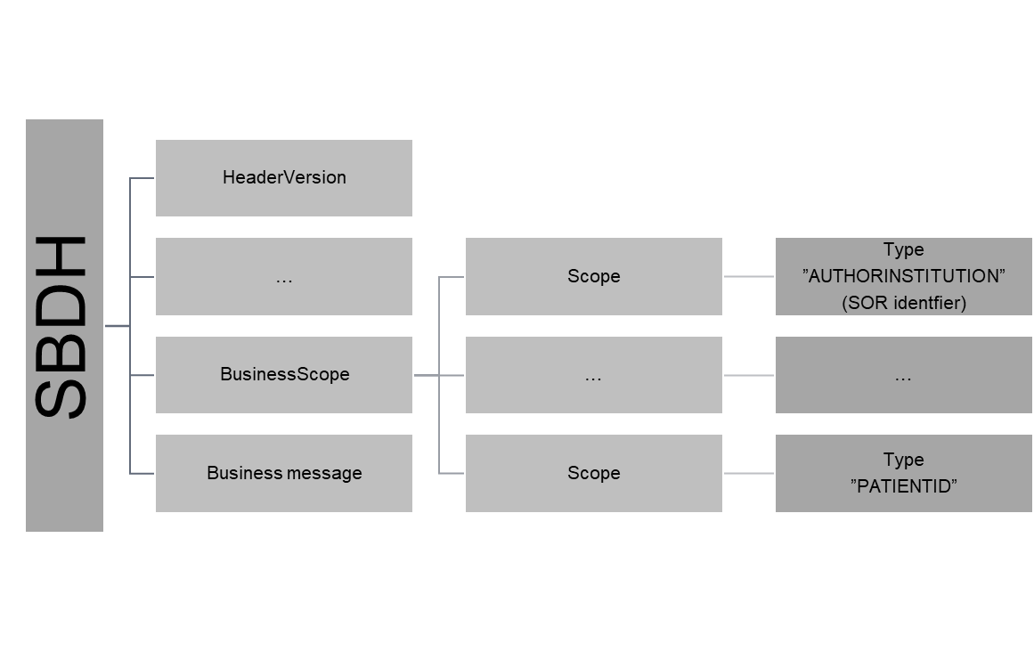

#### AUTHORINSTITUTION

<Scope>

<Type>AUTHORINSTITUTION</Type>

<InstanceIdentifier>

[Emessage/[LetterType]/Sender/OrganisationName]

+ ”^^^^^&amp;1.2.208.176.1.1&amp;ISO^^^^”

+ [Emessage/[LetterType]/Sender/Identifier]

</InstanceIdentifier>

<Identifier>dk-dds-authorInstitution</Identifier>

</Scope>

##### AUTHORINSTITUTION eksempel:

<Scope>

<Type>AUTHORINSTITUTION</Type>

<InstanceIdentifier>Odense Universitetshospital – Svendborg^^^^^&amp;1.2.208.176.1.1&amp;ISO^^^^8071000016009</ InstanceIdentifier>

<Identifier>dk-dds-authorInstitution</Identifier>

#### CLASSCODE

Altid “meddelelse”

<Scope>

<Type>CLASSCODE</Type>

<InstanceIdentifier>meddelelse</InstanceIdentifier>

<Identifier>dk-dds-displayName</Identifier>

</Scope>

<Scope>

<Type>CLASSCODE</Type>

<InstanceIdentifier>005</InstanceIdentifier>

<Identifier>dk-dds-code</Identifier>

</Scope>

<Scope>

<Type>CLASSCODE</Type>

<InstanceIdentifier>1.2.208.184.100.9</InstanceIdentifier>

<Identifier>dk-dds-codeSystem</Identifier>

</Scope>

#### CONFIDENTIALITYCODE

Altid N - “normal”

<Scope>

<Type>CONFIDENTIALITYCODE</Type>

<InstanceIdentifier>normal</InstanceIdentifier>

<Identifier>dk-dds-displayName</Identifier>

</Scope>

<Scope>

<Type>CONFIDENTIALITYCODE</Type>

<InstanceIdentifier>N</InstanceIdentifier>

<Identifier>dk-dds-code</Identifier>

</Scope>

<Scope>

<Type>CONFIDENTIALITYCODE</Type>

<InstanceIdentifier>2.16.840.1.113883.5.25</InstanceIdentifier>

<Identifier>dk-dds-codeSystem</Identifier>

</Scope>

#### CREATIONTIME

Format: YYYYMMDDhhmmss

<Scope>  
  <Type>CREATIONTIME</Type>  
 <InstanceIdentifier>

[Emessage/[LetterType]/Letter/authorization/date]+ [Emessage/[LetterType]/Letter/authorization/time] + ”00”

</InstanceIdentifier>  
<Identifier>dk-dds-metadata</Identifier>

</Scope>

##### CREATIONTIME eksempel:

<Scope>

<Type>CREATIONTIME</Type>

<InstanceIdentifier>202011061900</InstanceIdentifier>

<Identifier>dk-dds-metadata</Identifier>

</Scope>

#### ENTRYUUID

Som [MESSAGEIDENTIFIER]

<Scope>  
  <Type>ENTRYUUID</Type>  
 <InstanceIdentifier>[MESSAGEIDENTIFIER]</InstanceIdentifier>

<Identifier>dk-dds-metadata</Identifier>

</Scope>

##### ENTRYUUID eksempel:

<Scope>

<Type>ENTRYUUID</Type>

<InstanceIdentifier>

00a2f3bf-0970-4ed7-a9c2-9f7194d11333

</InstanceIdentifier>

<Identifier>dk-dds-metadata</Identifier>

</Scope>

#### FORMATCODE

Altid følgende

<Scope>

  <Type>FORMATCODE</Type>  
 <InstanceIdentifier>dk:medcom:meddelelse</InstanceIdentifier>

<Identifier>dk-dds-displayName</Identifier>

</Scope>

<Scope>

  <Type>FORMATCODE</Type>  
 <InstanceIdentifier>

urn:ad:dk:medcom:message:full

</InstanceIdentifier>

<Identifier>dk-dds-code</Identifier>

</Scope>

<Scope>

  <Type>FORMATCODE</Type>  
 <InstanceIdentifier> 1.2.208.184.100.10</InstanceIdentifier>

<Identifier>dk-dds-codeSystem</Identifier>

</Scope>

#### HEALTHCARE_FACILITY_TYPE_CODE

Tages fra DK_IHE_HealthcareFacilityTypeCode_VS, I praksis er der følgende data at vælge imellem for pilotdeltagerne:

|  |  |  |  |
| --- | --- | --- | --- |
|  | Displayname | Code | Codesystem |
| Hospital | hospital | 22232009 | 2.16.840.1.113883.6.96 |
| Kommune | hjemmesygepleje | 550621000005101 | 2.16.840.1.113883.6.96 |
| Lægepraksis | lægepraksis | 394761003 | 2.16.840.1.113883.6.96 |

<Scope>

<Type>HEALTHCARE_FACILITY_TYPE_CODE</Type>  
 <InstanceIdentifier>

[HEALTHCARE_FACILITY_TYPE_CODE displayName]

</InstanceIdentifier>  
<Identifier>dk-dds-displayName</Identifier>

</Scope>

<Scope>

<Type>HEALTHCARE_FACILITY_TYPE_CODE</Type>  
 <InstanceIdentifier>

[HEALTHCARE_FACILITY_TYPE_CODE code]

</InstanceIdentifier>

<Identifier>dk-dds-code</Identifier>

</Scope>

<Scope>

<Type>HEALTHCARE_FACILITY_TYPE_CODE</Type>  
 <InstanceIdentifier>

[HEALTHCARE_FACILITY_TYPE_CODE codesystem]

</InstanceIdentifier>

<Identifier>dk-dds-codeSystem</Identifier>

</Scope>

##### HEALTHCARE_FACILITY_TYPE_CODE eksempel:

<Scope>

<Type>HEALTHCARE_FACILITY_TYPE_CODE</Type>  
<InstanceIdentifier>hospital</InstanceIdentifier>  
<Identifier>dk-dds-displayName</Identifier>

</Scope>

<Scope>

<Type>HEALTHCARE_FACILITY_TYPE_CODE</Type>  
 <InstanceIdentifier>22232009</InstanceIdentifier>

<Identifier>dk-dds-code</Identifier>

</Scope>

<Scope>

<Type>HEALTHCARE_FACILITY_TYPE_CODE</Type>  
 <InstanceIdentifier>2.16.840.1.113883.6.96</InstanceIdentifier>

<Identifier>dk-dds-codeSystem</Identifier>

</Scope>

#### INTENDEDRECIPIENT

Modtagerorganisation

<Scope>  
 <Type>INTENDEDRECIPIENT</Type>  
 <InstanceIdentifier>

SBDH.BusinessScope.Scope.Type(“RECEIVERID”).value

</InstanceIdentifier>  
  <Identifier>dk-dds-metadata</Identifier>

</Scope>

##### INTENDEDRECIPIENT eksempel:

<Scope>  
 <Type>INTENDEDRECIPIENT</Type>  
 <InstanceIdentifier>1170102</InstanceIdentifier>  
  <Identifier>dk-dds-metadata</Identifier>

</Scope>

#### LANGUAGECODE

Altid “da-DK”

<Scope>  
 <Type>LANGUAGECODE</Type>  
 <InstanceIdentifier>da-DK</InstanceIdentifier>  
  <Identifier>dk-dds-metadata</Identifier>

</Scope>

#### LEGALAUTHENTICATOR

<Scope>

<Type>LEGALAUTHENTICATOR</Type>

<InstanceIdentifier>

”^” + [Emessage/[LetterType]/Sender/OrganisationName]

+ ^^

+ ^^^^^^^&amp;ISO

</InstanceIdentifier>

<Identifier>dk-dds-metadata</Identifier>

</Scope>

##### LEGALAUTHENTICATOR eksempel:

<Scope>

<Type>LEGALAUTHENTICATOR</Type>

<InstanceIdentifier>^Odense Universitetshospital – Svendborg^^^^^^^^^&amp;ISO</InstanceIdentifier>

<Identifier>dk-dds-metadata</Identifier>

</Scope>

#### MIMETYPE

Enten “fhir/json”, “fhir/xml” eller ”text/xml”

<Scope>  
 <Type>MIMETYPE</Type>  
 <InstanceIdentifier>[mimetype-value]</InstanceIdentifier>  
  <Identifier>dk-dds-metadata</Identifier>

</Scope>

##### MIMETYPE eksempel:

I piloten altid:

<Scope>  
 <Type>MIMETYPE</Type>  
 <InstanceIdentifier>text/xml</InstanceIdentifier>  
  <Identifier>dk-dds-metadata</Identifier>

</Scope>

#### OBJECTTYPE

Altid: urn:uuid:7edca82f-054d-47f2-a032-9b2a5b5186c1

<Scope>  
 <Type> OBJECTTYPE</Type>  
 <InstanceIdentifier>

urn:uuid:7edca82f-054d-47f2-a032-9b2a5b5186c1

</InstanceIdentifier>  
  <Identifier>dk-dds-metadata</Identifier>

</Scope>

#### PATIENTID

<Scope>

<Type>PATIENTID</Type>  
 <InstanceIdentifier>

[Emessage/[LetterType]/Patient/CivilRegistrationNumber] + ”^^^&amp;1.2.208.176.1.2&amp;ISO”

</InstanceIdentifier>  
  <Identifier>dk-dds-metadata</Identifier>

</Scope>

##### PATIENTID eksempel:

<Scope>

<Type>PATIENTID</Type>

<InstanceIdentifier>

0506504003^^^&amp;1.2.208.176.1.2&amp;ISO

</InstanceIdentifier>

<Identifier>dk-dds-metadata</Identifier>

</Scope>

#### PRACTICESETTINGCODE

Altid

<Scope>

<Type>PRACTICESETTINGCODE</Type>  
  <InstanceIdentifier>N/A</InstanceIdentifier>  
  <Identifier>dk-dds-metadata</Identifier>

</Scope>

#### SOURCEPATIENTID

Som PATIENTID

<Scope>

<Type>SOURCEPATIENTID</Type>  
 <InstanceIdentifier>

[Emessage/[LetterType]/Patient/CivilRegistrationNumber] + ”^^^&amp;1.2.208.176.1.2&amp;ISO”

</InstanceIdentifier>  
  <Identifier>dk-dds-metadata</Identifier>

</Scope>

##### SOURCEPATIENTID eksempel:

<Scope>

<Type>SOURCEPATIENTID</Type>  
<InstanceIdentifier>

0506504003^^^&amp;1.2.208.176.1.2&amp;ISO

</InstanceIdentifier>

<Identifier>dk-dds-metadata</Identifier>

</Scope>

#### SOURCEPATIENTINFO

<Scope>

<Type>SOURCEPATIENTINFO</Type>  
 <InstanceIdentifier>

”^”+[Emessage/[LetterType]/Patient/PersonSurnameName]+”^”+

[Emessage/[LetterType]/Patient/PersonGivenName]

</InstanceIdentifier>  
  <Identifier>dk-dds-metadata-PID5</Identifier>

</Scope>

<Scope>

<Type>SOURCEPATIENTINFO</Type>  
 <InstanceIdentifier>

DateOfBirth([PATIENTID])

</InstanceIdentifier>  
  <Identifier>dk-dds-metadata-PID7</Identifier>

</Scope>

<Scope>

<Type>SOURCEPATIENTINFO</Type>  
 <InstanceIdentifier>

Gender([PATIENTID])

</InstanceIdentifier>  
  <Identifier>dk-dds-metadata-PID8</Identifier>

</Scope>

##### SOURCEPATIENTINFO eksempel:

<Scope>

<Type>SOURCEPATIENTINFO</Type>

<InstanceIdentifier>^Matthiesen^Tjalfe</InstanceIdentifier>

<Identifier>dk-dds-metadata-PID5</Identifier>

</Scope>

<Scope>

<Type>SOURCEPATIENTINFO</Type>

<InstanceIdentifier>19500605</InstanceIdentifier>

<Identifier>dk-dds-metadata-PID7</Identifier>

</Scope>

<Scope>

<Type>SOURCEPATIENTINFO</Type>

<InstanceIdentifier>M</InstanceIdentifier>

<Identifier>dk-dds-metadata-PID8</Identifier>

</Scope>

#### TITLE

Meddelelsestypen + ”for” + PATIENTID

<Scope>  
 <Type>TITLE</Type>  
 <InstanceIdentifier>

[Emessage/[LetterType] + ”for” + [Emessage/[LetterType]/Patient/CivilRegistrationNumber]

</InstanceIdentifier>  
  <Identifier>dk-dds-metadata</Identifier>

</Scope>

##### TITLE eksempel:

<Scope>  
 <Type>TITLE</Type>  
 <InstanceIdentifier>

HospitalReferral for 010151-0101

</InstanceIdentifier>  
  <Identifier>dk-dds-metadata</Identifier>

</Scope>

#### TYPECODE

|  |  |  |
| --- | --- | --- |
| **Code** | **CodeSystem** | **DisplayName** |
| MedCom-OIOXML | 2.16.840.1.113883.6.1 | MedCom-OIOxml |
| MedCom-EDI | 2.16.840.1.113883.6.1 | MedCom-EDI |

<Scope>

<Type>TYPECODE</Type>  
 <InstanceIdentifier>

[TYPECODE displayName]

</InstanceIdentifier>  
<Identifier>dk-dds-displayName</Identifier>

</Scope>

<Scope>

<Type>TYPECODE</Type>  
 <InstanceIdentifier>

[TYPECODE code]

</InstanceIdentifier>

<Identifier>dk-dds-code</Identifier>

</Scope>

<Scope>

<Type>TYPECODE</Type>  
 <InstanceIdentifier>2.16.840.1.113883.6.1</InstanceIdentifier>  
 <Identifier>dk-dds-codeSystem</Identifier>

</Scope>

##### TYPECODE eksempel:

<Scope>

<Type>TYPECODE</Type>  
 <InstanceIdentifier>MedCom-OIOxml</InstanceIdentifier>  
<Identifier>dk-dds-displayName</Identifier>

</Scope>

<Scope>

<Type>TYPECODE</Type>  
 <InstanceIdentifier>MedCom-OIOXML</InstanceIdentifier>

<Identifier>dk-dds-code</Identifier>

</Scope>

<Scope>

<Type>TYPECODE</Type>  
 <InstanceIdentifier>2.16.840.1.113883.6.1</InstanceIdentifier>  
 <Identifier>dk-dds-codeSystem</Identifier>

</Scope>

## SBDH Reliable messaging & eDelivery SBDH-kvitteringer

Reliable messaging udløses af et request for hvilken grad af reliable messaging, der ønskes fra afsender, hvilket gøres vha. SBDHs BusinessService i BusinessScope elementet.

Når afsender har lavet et request for Reliable messaging og dermed brugen af SBDH-kvitteringer (acknowledgements) håndteres disse vha. ebXML Business Process Signals (ebBP Signals 2.0.4).

Udfaldsrum for disse ebXML Business Process Signals er:

* + - ReceiptAcknowledgement
    - ReceiptException
    - AcceptanceAcknowledgement (bruges pt ikke)

Der anvendes to strukturer

* + - Reliable messaging - BusinessService request
    - Reliable messaging - BusinessService response

Begge er bygget op omkring SBDHs BusinessScope/Scope element

I forbindelse med krav ifm. om Reliable messaging anvendes strukturen i BusinessScope kaldet BusinessService til at udforme, hvilken type af SBDH-transaktioner, som modtager af SBDH-originalkuverten skal opfylde.

* **ServiceTransaction**
* - TypeOfServiceTransaction
* - IsNonRepudiationRequired
* - IsAuthenticationRequired
* - IsNonRepudiationOfReceiptRequired
* - IsApplicationErrorResponseRequested
* - TimeToAcknowledgeReceipt
* - TimeToAcknowledgeAcceptance

CorrelationInformation bruges til at binde meddelelse og kvittering sammen. I piloten genereres alle elementer i CorrelationInformation af afsendende SBDH-MSH. Modtager af SBDH og afsender af SBDH ReceiptAcknowledgement skal kvittere med angivelse af CorrelationInformation elementerne RequestingDocumentCreationDateTime og RequestingDocumentInstanceIdentifier. Der kvitteres aldrig på en kvittering.

### Reliable messaging - BusinessService Request

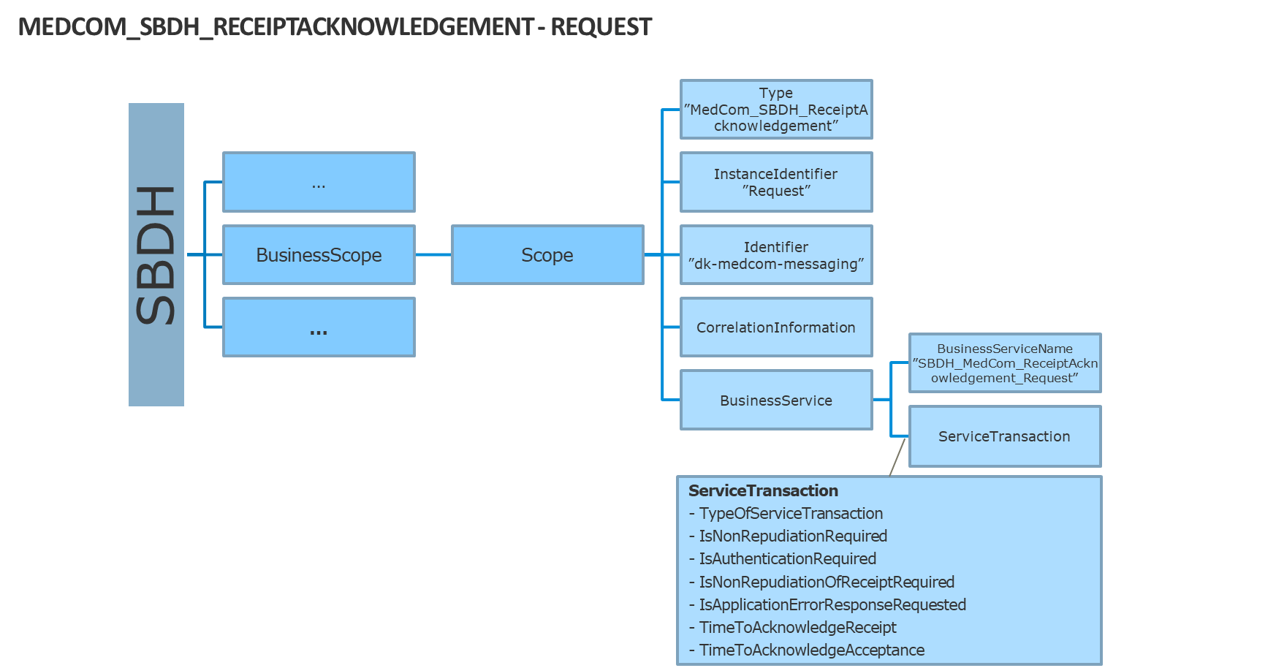

I det følgende er dette sat op som det ønskes i piloten.

#### MedCom_SBDH_ReceiptAcknowledgement - Request

I et MedCom_SBDH_ReceiptAcknowledgement - Request er scope altid dette:

<Scope>  
 <Type>MedCom_SBDH_ReceiptAcknowledgement</Type>  
 <InstanceIdentifier>Request</InstanceIdentifier>  
  <Identifier>dk-medcom-messaging</Identifier>

</Scope>

#### CorrelationInformation

Ifm. reliable messaging bruges SBDH’ens CorrelationInformation til at binde original SBDH og kvitterings SBDH sammen. Her anvendes specielt RequestingDocumentInstanceIdentifier

##### CorrelationInformation RequestingDocumentCreationDateTime

RequestingDocumentCreationDateTime er tidspunktet for original meddelelsens afsendelse = DocumentIdentification/CreationDateAndTime

<CorrelationInformation>

<RequestingDocumentCreationDateTime>

[YYYY-MM-DD]T[TT-MM-SS]+[offset to UTC]

</RequestingDocumentCreationDateTime>

…

<CorrelationInformation>

Eksempel:

<CorrelationInformation>

<RequestingDocumentCreationDateTime>

2021-02-17T09:30:10+01:00

</RequestingDocumentCreationDateTime>

…

<CorrelationInformation>

##### CorrelationInformation RequestingDocumentInstanceIdentifier

RequestingDocumentInstanceIdentifier er originalkuvertens identifier = DocumentIdentification/InstanceIdentifier

<CorrelationInformation>

…

<RequestingDocumentInstanceIdentifier>

thisSBDH/DocumentIdentification/InstanceIdentifier

</RequestingDocumentInstanceIdentifier>

…

<CorrelationInformation>

Eksempel:

<CorrelationInformation>

…

<RequestingDocumentInstanceIdentifier>

9a6ff82208de-5a6f-9670-9fa4b9d2f0dh

</RequestingDocumentInstanceIdentifier>

…

<CorrelationInformation>

##### CorrelationInformation ExpectedResponseDateTime

ExpectedResponseDateTime udtrykker den forventede tid, der max går indtil en SBDH response modtages. I piloten giver den 10 min, dvs. RequestingDocumentCreationDateTime + 10 min

<CorrelationInformation>

…

<ExpectedResponseDateTime>

[YYYY-MM-DD]T[TT-MM-SS]+[offset to UTC]

</ExpectedResponseDateTime>

<CorrelationInformation>

Eksempel:

<CorrelationInformation>

…

<ExpectedResponseDateTime>

2021-02-17T09:40:10+01:00

</ExpectedResponseDateTime>

<CorrelationInformation>

#### CorrelationInformation samlet eksempel

<CorrelationInformation>

<RequestingDocumentCreationDateTime>

2021-02-17T09:30:10+01:00

</RequestingDocumentCreationDateTime>

<RequestingDocumentInstanceIdentifier>

9a6ff82208de-5a6f-9670-9fa4b9d2f0dh

</RequestingDocumentInstanceIdentifier>

<ExpectedResponseDateTime>

2021-02-17T09:40:10+01:00

</ExpectedResponseDateTime>

</CorrelationInformation>

#### SBDH BusinessServices - Request

##### BusinessServiceName

Altid

<BusinessServiceName>

SBDH_MedCom_ReceiptAcknowledgement_Request

</BusinessServiceName>

##### ServiceTransaction – TypeOfServiceTransaction

TypeOfServiceTransaction=”RequestingServiceTransaction”

##### ServiceTransaction – IsNonRepudiationRequired

IsNonRepudiationRequired=”false” (i pilot false, ellers true)

##### ServiceTransaction – IsAuthenticationRequired

IsAuthenticationRequired=”false” (i pilot false, ellers true)

##### ServiceTransaction – IsNonRepudiationOfReceiptRequired

IsNonRepudiationOfReceiptRequired=”false” (i pilot false, ellers true)

##### ServiceTransaction – IsIntelligibleCheckRequired

IsIntelligibleCheckRequired=”false” (i pilot false, ellers true)

##### ServiceTransaction – IsApplicationErrorResponseRequested

IsApplicationErrorResponseRequested=”false” (i pilot false, ellers true)

##### ServiceTransaction – TimeToAcknowledgeReceipt

TimeToAcknowledgeReceipt=”600000” (ms)

##### ServiceTransaction – TimeToAcknowledgeAcceptance

TimeToAcknowledgeAcceptance=”0” (=bruges pt ikke)

##### ServiceTransaction – TimeToPerform

TimeToPerform=”0” (=bruges pt ikke)

##### ServiceTransaction - Recurrence

Recurrence=”0” (=bruges pt ikke)

#### SBDH BusinessServices - Request eksempel

<BusinessService>

<BusinessServiceName>

SBDH_MedCom_ReceiptAcknowledgement_Request

</BusinessServiceName>

<ServiceTransaction

TypeOfServiceTransaction=”RequestingServiceTransaction”, IsNonRepudiationRequired=”false”,

IsAuthenticationRequired=”false”, IsNonRepudiationOfReceiptRequired=”false”, IsIntelligibleCheckRequired=”false”, IsApplicationErrorResponseRequested=”false”, TimeToAcknowledgeReceipt=”300000”,

TimeToAcknowledgeAcceptance=”0”,

TimeToPerform=”0”,

Recurrence=”0”/>

</BusinessService>

#### Reliable messaging - BusinessService Request samlet eksempel

<BusinessScope>

<Scope>  
 <Type>MedCom_SBDH_ReceiptAcknowledgement</Type>  
 <InstanceIdentifier>Request</InstanceIdentifier>  
  <Identifier>dk-medcom-messaging</Identifier>

<CorrelationInformation>

<RequestingDocumentCreationDateTime>

2021-02-17T09:30:10+01:00

</RequestingDocumentCreationDateTime>

<RequestingDocumentInstanceIdentifier>

9a6ff82208de-5a6f-9670-9fa4b9d2f0dh

</RequestingDocumentInstanceIdentifier>

<ExpectedResponseDateTime>

2021-02-17T09:40:10+01:00

</ExpectedResponseDateTime>

</CorrelationInformation>

<BusinessService>

<BusinessServiceName>

SBDH_MedCom_ReceiptAcknowledgement_Request

</BusinessServiceName>

<ServiceTransaction

TypeOfServiceTransaction=”RequestingServiceTransaction”, IsNonRepudiationRequired=”false”,

IsAuthenticationRequired=”false”, IsNonRepudiationOfReceiptRequired=”false”, IsIntelligibleCheckRequired=”false”, IsApplicationErrorResponseRequested=”false”, TimeToAcknowledgeReceipt=”300000”,

TimeToAcknowledgeAcceptance=”0”,

TimeToPerform=”0”,

Recurrence=”0”/>

</BusinessService>

</Scope>

…

</BusinessScope>

### Reliable messaging - BusinessService Response

I det følgende er dette sat op som det ønskes i piloten.

#### MedCom_SBDH_ReceiptAcknowledgement - Response

I et MedCom_SBDH_ReceiptAcknowledgement - Response er scope altid dette:

<Scope>  
 <Type>MedCom_SBDH_ReceiptAcknowledgement</Type>  
 <InstanceIdentifier>Response</InstanceIdentifier>  
  <Identifier>dk-medcom-messaging</Identifier>

</Scope>

#### CorrelationInformation

Ifm. reliable messaging bruges SBDH’ens CorrelationInformation til at binde original SBDH og kvitterings SBDH sammen. Her anvendes specielt RequestingDocumentInstanceIdentifier

##### CorrelationInformation RequestingDocumentCreationDateTime

RequestingDocumentCreationDateTime er tidspunktet for originalkuvertens afsendelse = OriginalSBDH/RequestingDocumentCreationDateTime

<CorrelationInformation>

<RequestingDocumentCreationDateTime>

[YYYY-MM-DD]T[TT-MM-SS]+[offset to UTC]

</RequestingDocumentCreationDateTime>

…

<CorrelationInformation>

###### RequestingDocumentCreationDateTime eksempel

<CorrelationInformation>

<RequestingDocumentCreationDateTime>

2021-02-17T09:30:10+01:00

</RequestingDocumentCreationDateTime>

…

<CorrelationInformation>

##### CorrelationInformation RequestingDocumentInstanceIdentifier

RequestingDocumentInstanceIdentifier er originalkuvertens identifier = OriginalSBDH/RequestingDocumentInstanceIdentifier

<CorrelationInformation>

…

<RequestingDocumentInstanceIdentifier>

RequestingSBDH/RequestingDocumentInstanceIdentifier

</RequestingDocumentInstanceIdentifier>

…

<CorrelationInformation>

###### RequestingDocumentInstanceIdentifier eksempel

<CorrelationInformation>

…

<RequestingDocumentCreationDateTime>

9a6ff82208de-5a6f-9670-9fa4b9d2f0dh

</RequestingDocumentCreationDateTime>

…

<CorrelationInformation>

##### CorrelationInformation ExpectedResponseDateTime

ExpectedResponseDateTime udelades i en SBDH ReceiptAcknowledgement

##### CorrelationInformation samlet eksempel

<CorrelationInformation>

<RequestingDocumentCreationDateTime>

2021-02-17T09:30:10+01:00

</RequestingDocumentCreationDateTime>

<RequestingDocumentInstanceIdentifier>

9a6ff82208de-5a6f-9670-9fa4b9d2f0dh

</RequestingDocumentInstanceIdentifier>

</CorrelationInformation>

#### SBDH BusinessServices - Response

##### BusinessServiceName

Altid

<BusinessServiceName>

SBDH_MedCom_ReceiptAcknowledgement_Response

</BusinessServiceName>

##### ServiceTransaction – TypeOfServiceTransaction

Altid

TypeOfServiceTransaction=”RespondingServiceTransaction”

##### ServiceTransaction – IsNonRepudiationRequired

Altid

IsNonRepudiationRequired=”false” (i pilot false, ellers true)

##### ServiceTransaction – IsAuthenticationRequired

Altid

IsAuthenticationRequired=”false” (i pilot false, ellers true)

##### ServiceTransaction – IsNonRepudiationOfReceiptRequired

Altid

IsNonRepudiationOfReceiptRequired=”false” (i pilot false, ellers true)

##### ServiceTransaction – IsIntelligibleCheckRequired

Altid

IsIntelligibleCheckRequired=”false” (i pilot false, ellers true)

##### ServiceTransaction – IsApplicationErrorResponseRequested

Altid

IsApplicationErrorResponseRequested=”false” (i pilot false, ellers true)

##### ServiceTransaction – TimeToAcknowledgeReceipt

Altid

TimeToAcknowledgeReceipt=”0” (ms)

##### ServiceTransaction – TimeToAcknowledgeAcceptance

Altid

TimeToAcknowledgeAcceptance=”0” (=bruges pt ikke)

##### ServiceTransaction – TimeToPerform

Altid

TimeToPerform=”0” (=bruges pt ikke)

##### ServiceTransaction - Recurrence

Altid

Recurrence=”0” (=bruges pt ikke)

#### SBDH BusinessServices - Response eksempel

<BusinessService>

<BusinessServiceName>

SBDH_MedCom_ReceiptAcknowledgement_Response

</BusinessServiceName>

<ServiceTransaction

TypeOfServiceTransaction=”RequestingServiceTransaction”, IsNonRepudiationRequired=”false”,

IsAuthenticationRequired=”false”, IsNonRepudiationOfReceiptRequired=”false”, IsIntelligibleCheckRequired=”false”, IsApplicationErrorResponseRequested=”false”, TimeToAcknowledgeReceipt=”300000”,

TimeToAcknowledgeAcceptance=”0”,

TimeToPerform=”0”,

Recurrence=”0”/>

</BusinessService>

#### Reliable messaging - BusinessService Response samlet eksempel

<BusinessScope>

<Scope>  
 <Type>MedCom_SBDH_ReceiptAcknowledgement</Type>  
 <InstanceIdentifier>Response</InstanceIdentifier>  
  <Identifier>dk-medcom-messaging</Identifier>

<CorrelationInformation>

<RequestingDocumentCreationDateTime>

2021-02-17T09:30:10+01:00

</RequestingDocumentCreationDateTime>

<RequestingDocumentInstanceIdentifier>

9a6ff82208de-5a6f-9670-9fa4b9d2f0dh

</RequestingDocumentInstanceIdentifier>

</CorrelationInformation>

<BusinessService>

<BusinessServiceName>

SBDH_MedCom_ReceiptAcknowledgement_Response

</BusinessServiceName>

<ServiceTransaction

TypeOfServiceTransaction=”RespondingServiceTransaction”, IsNonRepudiationRequired=”false”,

IsAuthenticationRequired=”false”, IsNonRepudiationOfReceiptRequired=”false”, IsIntelligibleCheckRequired=”false”, IsApplicationErrorResponseRequested=”false”, TimeToAcknowledgeReceipt=”0”,

TimeToAcknowledgeAcceptance=”0”,

TimeToPerform=”0”,

Recurrence=”0”/>

</BusinessService>

</Scope>

…

</BusinessScope>

### SBDH ReceiptAcknowledgement

SBDH ReceiptAcknowledgement anvendes som positiv transportkvittering, og for at modtager af kvitteringen nemt kan korrelere meddelelse med originalkuverten, kan modtager checke på hhv.

* Sender
  + Identifier (GLN-nummer for afsender)
* Receiver
  + Identifier (GLN-nummer for modtager)
* Scope
  + SENDERID (SORID for afsender)
  + RECEIVERID (SORID for modtager)
  + CorrelationInformation
    - RequestingDocumentInstanceIdentifier

Indlejret i en SBDH ReceiptAcknowledgement er også en ebbp-signal, som i princippet indeholder de samme informationer, men som det ikke er nødvendigt at checke, når det er en ReceiptAcknowledgement.

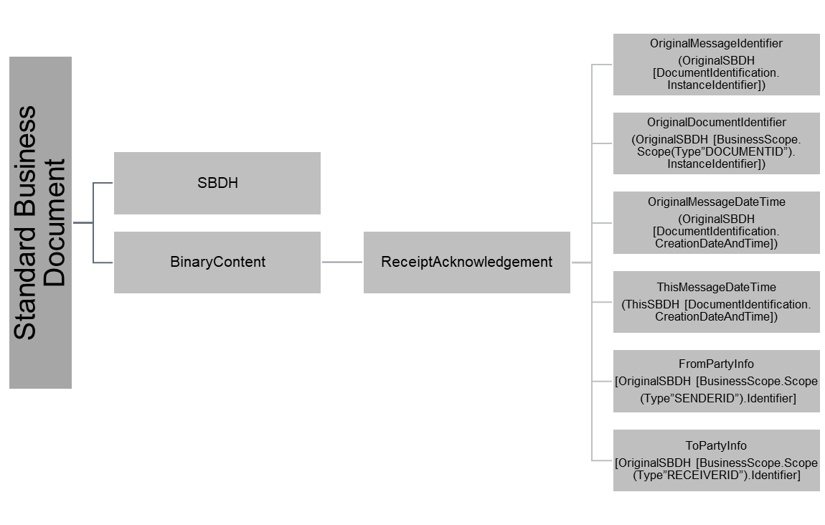

The Receipt Acknowledgement Business Signal signals that a message has been properly received by the Receiver MSH software component. Legible means that it has passed structure/schema validity check. The content of the receipt and the legibility of a business message MUST be reviewed prior to the processing of the Requesting or Responding Business Document or the evaluation of condition expressions in the message's Business Documents or Document Envelope. Condition Expressions are expressions that evaluate to true or false. [ebxmlbp]

##### OriginalMessageIdentifier

Same datatype as SBDH.DocumentIdentification.InstanceIdentifier

<bpssignal:OriginalMessageIdentifier>

[OriginalSBDH.DocumentIdentification.InstanceIdentifier]

</bpssignal:OriginalMessageIdentifier>

###### OriginalMessageIdentifier eksempel

<bpssignal:OriginalMessageIdentifier>

9a6ff822-08de-5a6f-9670-9fa4b9d2f0dc

</bpssignal:OriginalMessageIdentifier>

##### OriginalDocumentIdentifier

Same datatype as SBDH.BusinessScope…DOCUMENTID.InstanceIdentifier

<bpssignal:OriginalDocumentIdentifier>

[OriginalSBDH.BusinessScope…DOCUMENTID.InstanceIdentifier]

</bpssignal:OriginalDocumentIdentifier>

###### OriginalDocumentIdentifier eksempel

<bpssignal:OriginalDocumentIdentifier>

urn:dk:healthcare:medcom:oioxml:schema:xsd:HospitalReferral##urn:www.medcom.dk:messaging:HospitalReferral/Letter/TypeCode/XREF01::HospitalReferral/Letter/VersionCode/XH0130R

</bpssignal:OriginalDocumentIdentifier>

##### OriginalMessageDateTime

Altid på formen: [YYYY-MM-DD]T[tt:mm:ss]+[offset-to-UTC]

<bpssignal:OriginalMessageDateTime>

[OriginalSBDH.DocumentIdentification.CreationDateAndTime]

</bpssignal:OriginalMessageDateTime>

###### OriginalMessageDateTime eksempel

<<bpssignal:OriginalMessageDateTime>

2020-11-06T16:19:00+01.00

</bpssignal:OriginalMessageDateTime>

##### ThisMessageDateTime

Altid på formen: [YYYY-MM-DD]T[tt:mm:ss]+[offset-to-UTC]

<bpssignal:ThisMessageDateTime>

[ThisSBDH.DocumentIdentification.CreationDateAndTime]

</bpssignal:ThisMessageDateTime>

###### ThisMessageDateTime eksempel

<bpssignal:ThisMessageDateTime>

2020-11-06T16:19:10+01.00

</bpssignal:ThisMessageDateTime>

##### FromPartyInfo

<bpssignal:FromPartyInfo type=[OriginalSBDH:Receiver.Identifier@Authority]>

[OriginalSBDH:Receiver.Identifier]

</bpssignal:FromPartyInfo>

###### FromPartyInfo eksempel

<bpssignal:FromPartyInfo type=”iso6523-actorid-upis”>

0088:5790000201389

</bpssignal:FromPartyInfo>

##### ToPartyInfo

<bpssignal:ToPartyInfo type=[OriginalSBDH:Sender.Identifier@Authority]>

[OriginalSBDH:Sender.Identifier]

</bpssignal:ToPartyInfo>

###### ToPartyInfo eksempel

<bpssignal:ToPartyInfo type=”iso6523-actorid-upis”>

0088:5790000121526

</bpssignal:ToPartyInfo>

### Receipt Acknowledgement Exception

A Receipt Exception signals an error condition in the management of a Business Transaction. This Business Signal is returned to the initiating activity that originated the request. This exception MUST terminate the Business Transaction. These errors deal with the mechanisms of message exchange such as verification, validation, authentication and authorization and will occur up to message acceptance. Typically the rules and constraints applied to the message will have only dealt with the well-formedness of the message.

A receipt exception terminates the Business Transaction. The following are receipt exceptions:

* Syntax exceptions. There is invalid punctuation, vocabulary or grammar in the Business Document or Business Signal.
* Authorization exceptions. Roles are not authorized to participate in the BTA. Note that the receiving BSI can only identify this exception.
* Signature exceptions. Business Documents are not signed for non-repudiation when required.
* Sequence exceptions. The order or type of a Business Document or Business Signal is incorrect.

A Receipt Exception typicall Signals an error condition in a Business Activity which requires a transaction to be terminated, i.e. receipt of a business message with a Business Document that has failed. (From [ebxmlbp] page 77)

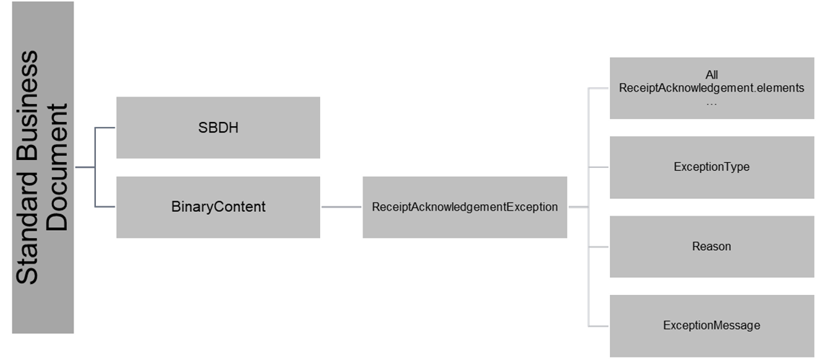

##### OriginalMessageIdentifier

Som 4.7.3.1.1

##### OriginalDocumentIdentifier

Som 4.7.3.1.2

##### OriginalMessageDateTime

Som 4.7.3.1.3

##### ThisMessageDateTime

Som 4.7.3.1.4

##### FromPartyInfo

Som 4.7.3.1.5

##### ToPartyInfo

Som 4.7.3.1.6

##### ExceptionType

Indholdet defineres overordnet som en ReceiptException, men derudover er det modtagerens fejlhåndteringsmekanismes logik, der bestemmer indholdet. Her eksemplificeret fra MedComs Gateway service. Reason og ExceptionMessage følger samme logik.

<bpssignal:ExceptionType>  
 <bpssignal:ReceiptException>

[Syntax]

</bpssignal:ReceiptException>

</bpssignal:ExceptionType>

###### ExceptionType eksempel

<bpssignal:ExceptionType>  
 <bpssignal:ReceiptException>

<GeneralException>101</GeneralException>

</bpssignal:ReceiptException>

</bpssignal:ExceptionType>

##### Reason

Se ExceptionType

<bpssignal:Reason>

[Reason]

</bpssignal:Reason>

###### Reason eksempel

<bpssignal:Reason>

Internal error

</bpssignal:Reason>

##### ExceptionMessage

Se ExceptionType

<bpssignal:ExceptionMessage>

[ExceptionMessage]

</bpssignal:ExceptionMessage>

###### ExceptionMessage eksempel

<bpssignal:ExceptionMessage>

javax.xml.bind.UnmarshalException

- with linked exception:

[org.xml.sax.SAXParseException; lineNumber: 7; columnNumber: 21; The end-tag for element type "ns3:Sender" must end with a '&gt;' delimiter.]

</bpssignal:ExceptionMessage>

## SBDH BinaryContent – den indeholdte meddelelse

BinaryContent er en SBDH 1.2 udvidelse, der giver mulighed for at wrappe specifikt indhold i SBDH og base64-encode det. MimeType tydeliggør indholdet, og hvad modtager kan forvente af base64-decodingen.

Udfaldsrum for mimeType er:

* + - text/xml
    - text/edi
    - fhir/xml
    - fhir/json

<BinaryContent xmlns="http://peppol.eu/xsd/ticc/envelope/1.0" mimeType=[mimeType] encoding=[encoding]>

[base64-encoded indhold]

<BinaryContent>

Encoding vil i piloten have følgende udfaldsrum for MedCom meddelelserne, som alle er OIOxml:

* + - "UTF-8"
    - ”ISO-8859-1”

Encoding vil i piloten have følgende udfaldsrum for ReceiptAcknowledgement og ReceiptAcknowledgmentException:

* + - "UTF-8"

# SBDH i brugsscenarier

## 4-corner

SBDH bruges som ovenfor specificeret

## 3-corner (gateway-scenarier)

Ny SBDH anvendes på hvert ben i forsendelsen.

Hvad ændres i SBDH mellem de forsendelser:

1. ny Documentation/InstanceIdentifier
2. ny Documentation/CreationDateAndTime
3. ProcessId ændres fra
   1. ”fod-emergence” til ”fod-distribution”
   2. Eller ”sdn-emergence” til ”sdn-distribution”

# SMP (Service Metadata Publisher)

# Bilag A: Policies for konfiguration af SMP og SBDH

I dansk eDelivery på sundhedsområdet forsøger vi i så vid udstrækning som muligt at lægge os så tæt op ad PEPPOL specifikationerne. Hvor PEPPOL specifikationerne ikke giver mening, f.eks. ved referencer til specifikke dokumenttyper, der kun giver mening i PEPPOL verdenen, angiver vi

Denne konfiguration tager udgangspunkt i [Policy_identifiers], som består af en lang række policies, som en PEPPOL installation skal overholde. I det følgende beskrives kun afvigelser fra [Policy_identifiers], policies som altså ikke beskrives explicit i nærværende dokument, videreføres uændret.

### Generelt vedrørende identifiers

Følgende policies vedrørende Identifiers følges uændret i dette dokument:

* **POLICY 1 Usage of ISO15459**
* **POLICY 2 Identifier Value casing**

### Konfiguration af ParticipantIdentifier (SMP)/Party Identification (SBDH)

#### SMP

SignedServiceMetadata/ServiceMetadata/ServiceInformation/ParticipantIdentifier

##### Format

Følgende policies vedrørende ParticipantIdentifier følges uændret i dette dokument:

* **POLICY 3 Use of ISO15459 structure**
* **POLICY 4 Coding of Identifier Schemes**

##### Identifier Scheme values

Følgende policies vedrørende ParticipantIdentifier følges uændret i dette dokument:

* **POLICY 5 Participant Identifier Meta Scheme**
* **POLICY 6 Numeric Codes for Identifier Schemes**
* **POLICY 7 Participant Identifiers for DNS**
* **POLICY 8 XML attributes for Participant Identifiers in SMP responses**
* **POLICY 11 XML attributes for Participant Identifiers in the Envelope (SBDH)**

Følgende policies vedrørende ParticipantIdentifier følges ikke i dette dokument:

* **POLICY 9 XML attributes for Electronic Address IDs (EndpointID) in UBL documents**
* **POLICY 10 XML attributes for Electronic address IDs in CII documents**

Men erstattes i dette dokument af:

* **DKEDEL POLICY 9 XML attributes for Electronic Address IDs (EndpointID) in MedCom documents**

##### [TBD] DKEDEL POLICY 9 XML attributes for Electronic Address IDs (EndpointID) in MedCom documents

##### Konfiguration af ParticipantIdentifier i dansk eDelivery

Heraf følger at ParticipantIdentifier må udtrykkes således:

***<ParticipantIdentifier scheme="iso6523-actorid-239 upis">0088:[SOR-Lokationsnummer]</ParticipantIdentifier>***

**Alternativer?:**

*<!-- GS1 ????? -->*

*<!--ns0:ParticipantIdentifier scheme="GLN">0088:[SOR-Lokationsnummer]</ns0:ParticipantIdentifier-->*

#### Konfiguration af Party Identification (SBDH)

##### Format

Følgende policies vedrørende Party Identification Identifiers følges uændret i dette dokument:

* **POLICY 12 Use of ISO15459 structure**
* **POLICY 13 Coding of Identifier Schemes**

Følgende policies vedrørende Party Identification Identifiers følges ikke i dette dokument:

* **POLICY 14 XML attributes for Party Identifiers in UBL documents**
* **POLICY 15 XML attributes for Party Identifiers in CII documents**

Men erstattes i dette dokument af:

* **POLICY 14x XML attributes for Party Identifiers in MedCom documents**

#### [TBD] POLICY 14x XML attributes for Party Identifiers in MedCom documents

### Konfiguration af DocumentIdentifier

(SignedServiceMetadata/ServiceMetadata/ServiceInformation/DocumentIdentifier)

* **Peppol POLICY 10 erstattes af: MedCom POLICY 10 - MedCom Document Type Identifier scheme**

The MedCom document type identifier scheme to be used is:

medcom-docid-qns

Applies to: all document type identifiers in all components

* **POLICY 11 PEPPOL Customization Identifiers**

The Customization Identifier is defined in the relevant PEPPOL BIS specification. A PEPPOL Access Point MUST treat the identifier as an atomic string. The definition of the customization identifier within the BIS specifications should be defined according to the CEN BII rules.

Applies to: all document type identifiers in all components

Heraf følger at DocumentIdentifier må/kan se således ud:

***<DocumentIdentifier scheme="medcom-docid-qns"> urn:dk:healthcare:medcom:oioxml:schema:xsd:ClinicalEmail ## urn:www.medcom.dk:messaging:XDIS91::XD9134L</DocumentIdentifier>***

For alle værdier som documentidentifier kan antage mht. version og type henvises til MedComs standardkatalog: <https://svn.medcom.dk/svn/releases/MedComs%20Standardkatalog.xlsx>

#### Policies on Identifying Document Types (supported by MedCom)

Følgende policies vedrørende Identifying Document Typesfølges uændret i dette dokument:

* **POLICY 16 Document Type Identifier scheme**
* **POLICY 17 Customization Identifiers**
* **POLICY 20 Document Type Identifier Value pattern**
* **POLICY 21 Specifying Document Type Identifiers in SMP documents**
* **POLICY 22 Specifying Document Type Identifiers in the Envelope (SBDH)**
* **POLICY 23 Document Type Identifier Values**

Følgende policies vedrørende Identifying Document Typesfølges ikke i dette dokument:

* **POLICY 18 Specifying Customization Identifiers in UBL documents**
* **POLICY 19 Specifying Customization Identifiers in CII documents**

Men erstattes i dette dokument af:

* **POLICY 18x Specifying Customization Identifiers in MedCom documents**

#### [TBD] POLICY 18x Specifying Customization Identifiers in MedCom documents

### Konfiguration af ProcessIdentifier

(SignedServiceMetadata/ServiceMetadata/ServiceInformation/ProcessIdentifier)

**Policies on Identifying Processes supported by PEPPOL**

#### Policy for MedCom Process Identifiers

Følgende PEPPOL policies vedrørende Process Identifiers ændres i DKEDEL:

* **POLICY 24 Process Identifier scheme**
* **POLICY 25 Process Identifier Value**
* **POLICY 26 Specifying Process Identifiers in the Envelope (SBDH)**
* **POLICY 27 Specifying Process Identifiers in SMP documents**

##### DKEDEL POLICY 24 Process Identifier scheme

The DKEDEL Process Identifier Scheme is: dk-messaging

Applies to: all Process Identifiers in all components

Note: this scheme identifier is always case sensitive

##### DKEDEL POLICY 25 Process Value

All valid Process Identifier Values are defined in [DKEDEL_PIV_CodeList].

Process Identifier Values MUST NOT contain whitespace characters.

Applies to: all Process Identifiers in all components

The Process Identifier is defined in the relevant DKEDEL specification. A DKEDEL Access Point MUST treat the identifier as an atomic string. The definition of the process identifier within the DKEDEL specifications should be defined according to the DKEDEL rules.

Applies to: all process identifiers in all component

##### DKEDEL POLICY 26 Specifying Process Identifiers in the Envelope (SBDH)

##### DKEDEL POLICY 27 Specifying Process Identifiers in SMP documents

The value for the scheme attribute should be be “dk-messaging” (see DKEDEL POLICY 24) and the element value must be the process identifier itself.

Applies to: XML documents used in the SMP

<ProcessIdentifier scheme="dk-messaging">urn:www.digst.dk:profile:sdn-emergence </ProcessIdentifier>

<ProcessIdentifier scheme="dk-messaging">urn:www.digst.dk:profile:sdn-distribution </ProcessIdentifier>

<ProcessIdentifier scheme="dk-messaging"> urn:www.digst.dk:profile:fod-emergence </ProcessIdentifier>

<ProcessIdentifier scheme="dk-messaging"> urn:www.digst.dk:profile:fod-distribution </ProcessIdentifier>

**dk-messaging Process Identifier values**

|  |  |  |
| --- | --- | --- |
|  | **Process Identifier value** |  |
| sdn-emergence | urn:www.digst.dk:profile:sdn-emergence |  |
| sdn-distribution | urn:www.digst.dk:profile:sdn-distribution |  |
| fod-emergence | urn:www.digst.dk:profile:fod-emergence |  |
| fod-distribution | urn:www.digst.dk:profile:fod-distribution |  |

### Konfiguration af “Transport Profiles” i SMP

(SignedServiceMetadata/ServiceMetadata/ServiceInformation/[TBD])

#### Policy on Identifying Transport Profiles in SMP

Følgende PEPPOL policies vedrørende Identifying Transport Profiles er ændret i dette dokument:

* **POLICY 28 Transport Profile Values**
* **POLICY 29 Specifying Transport Profiles in SMP documents**

##### POLICY 28 Transport Profile Values

All valid Transport Profile Values are defined in [DKEDEL_TP_CodeList].

Applies to: all XML documents used in the SMP Rows in [DKEDEL_TP_CodeList]. marked as "deprecated" should not be used for newly issued documents. It is important to note that this is a dynamic list. Over time new services will be added. Developers should take this into account when designing and implementing solutions for DKEDEL services.

##### POLICY 29X Specifying Transport Profiles in SMP documents

The Transport Profile identifier must be placed in the “transportProfile” attribute of the SMP “Endpoint” element.

The value of the “transportProfile” attribute is case sensitive.

Applies to: all XML documents used in the SMP

Eksempel på den eneste mulighed i dansk eDelivery:

<Endpoint transportProfile="peppol-transport-as4-v2_0">

...

</Endpoint>